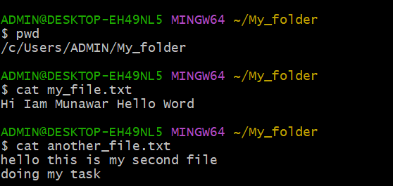
- Created directory
- Created two files
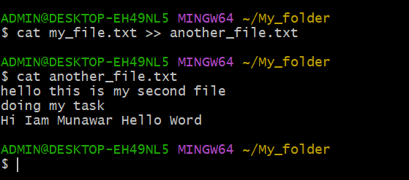
- Concatenate the content from “my_file to another_file.
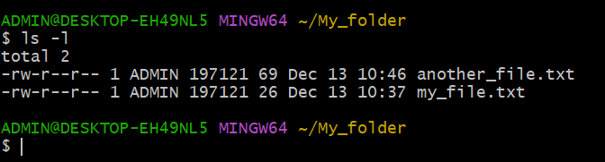
- Finally attached the screenshot which shows files and directories in the current directory.
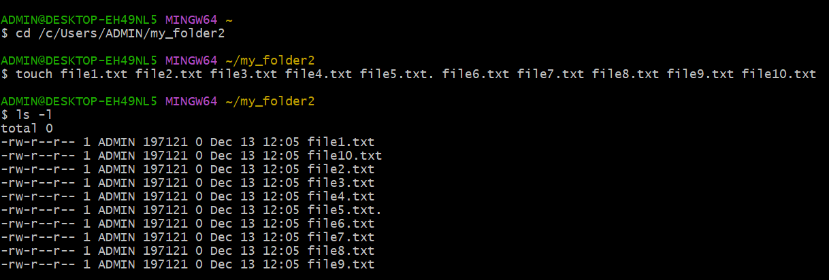
- Created 10 files with txt
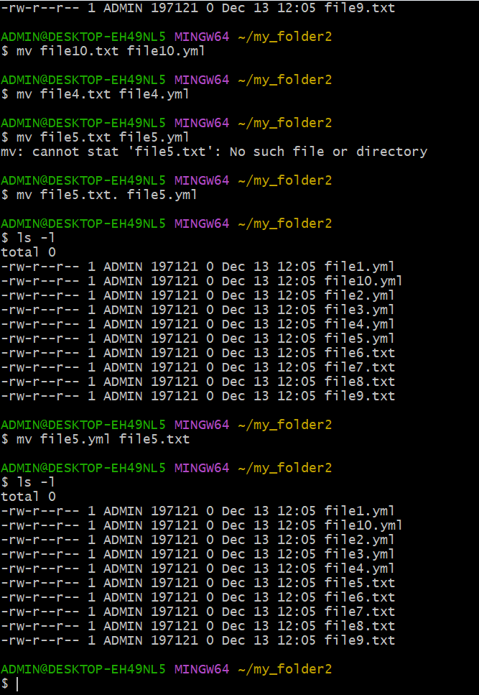
- Renamed first 5 files to YML as mention.

